LA-SHOP is a franchised shopping Mall with outlets throughout the world. The malls are located in Europe, North America and Australasia regions.

LA Shop are looking to use business intelligence to help drive their business.

Consider:
- Who are the stakeholders of LA Shop?
- What would be some potential aims and objectives for LA Shop.
- Choose one of these aims/objectives further consider.
  - What could they investigate to understand better the present situation?
  - What reports would help this this?
  - What data is required for the report?
  - Draw out an example illustration of this report (maybe use excel).
- How would LA shop know if they had been effective in reaching their objective?
  - Can the above report(s) include year on year trends?
  - Is there other information that would be useful?
- Consider specifically for the reports the dimensions, ie variables to consider against each other (time … cost … product … location …) and the facts (no_of_shops, …)
- We will come together to discuss the nature of these reports and a data store to support these reports.

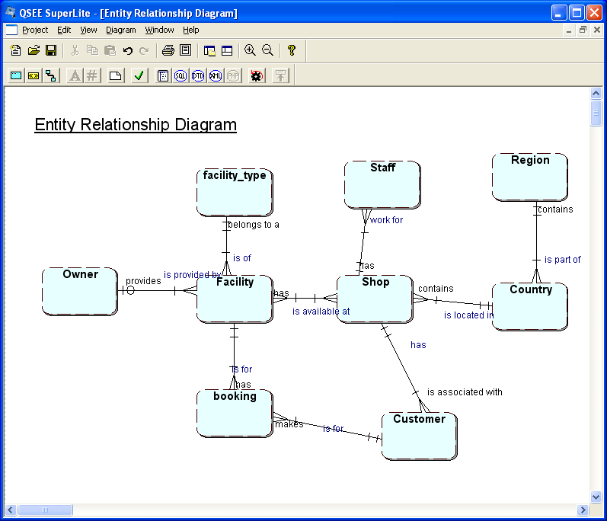

This is an example of the data model for one shopping mall

Data Analysis Exercise

Consider the data for the tables below:

Booking(booking_id, Customer_id, nursery_id, date_booked, booking_start_time, Booking_end_time, booked_by, no_in_party, special_notes)
Customer(Customer_id, customer_name, customer_address, customer_type)
Booking
1 | 100 | 70 | 01/01/2008 | 09:30 | 12:30 | null | 1 | own food provided
3 | 100 | 71 | 01/01/2010 | 10:00 | null | AB | 2 | doesn't know end time
5 | 101 | 72 | 02/01/2008 | 11:00 | 13:00 | AB | one
Customer
100 | Alan Abbots | 1 Ascot Ave | A
101 | Ben Bloggs | 2 Blue Boulevard | A
103 | Charlie Chaplin | 3 Cool Crescent | New

What are the problems, anomalies, issues with the data above ?
Make a suggestion as to how to address each case.

